**5 Weakness in DVWA**

**Installation of Kali Linux:** Date: 08/10 Time: 13:30

Step 1: Download Kali Linux's ISO File

Step 2: Create a New Virtual Machine.

Step 3: Select the iso file which we downloaded.

Step 4: Enter how much processor to give how much space to allocate.

Step 5: Setup the remaining configuration and your Kali Linux is ready.

I have done the following setting:

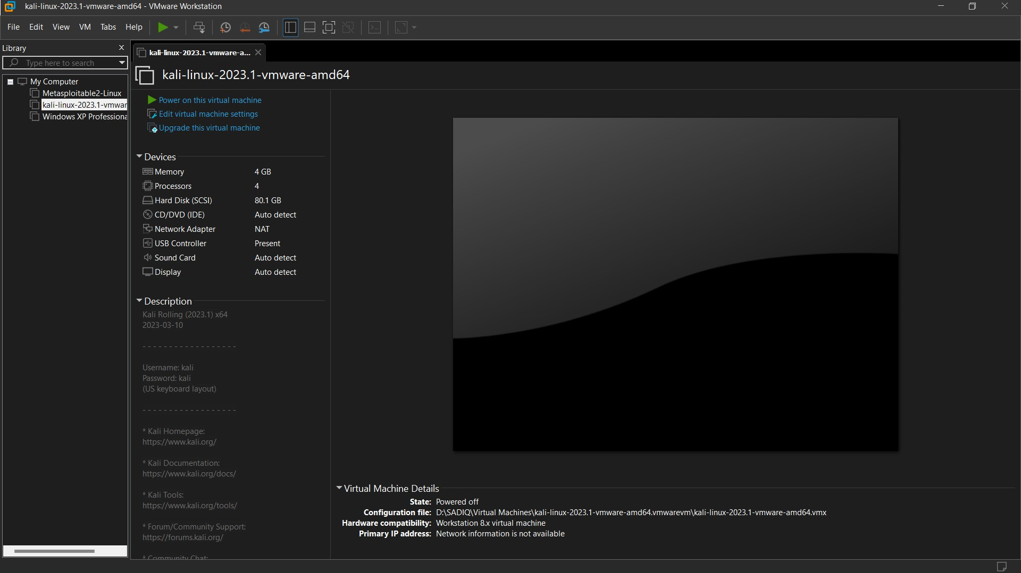

This is the homepage of Kali Linux

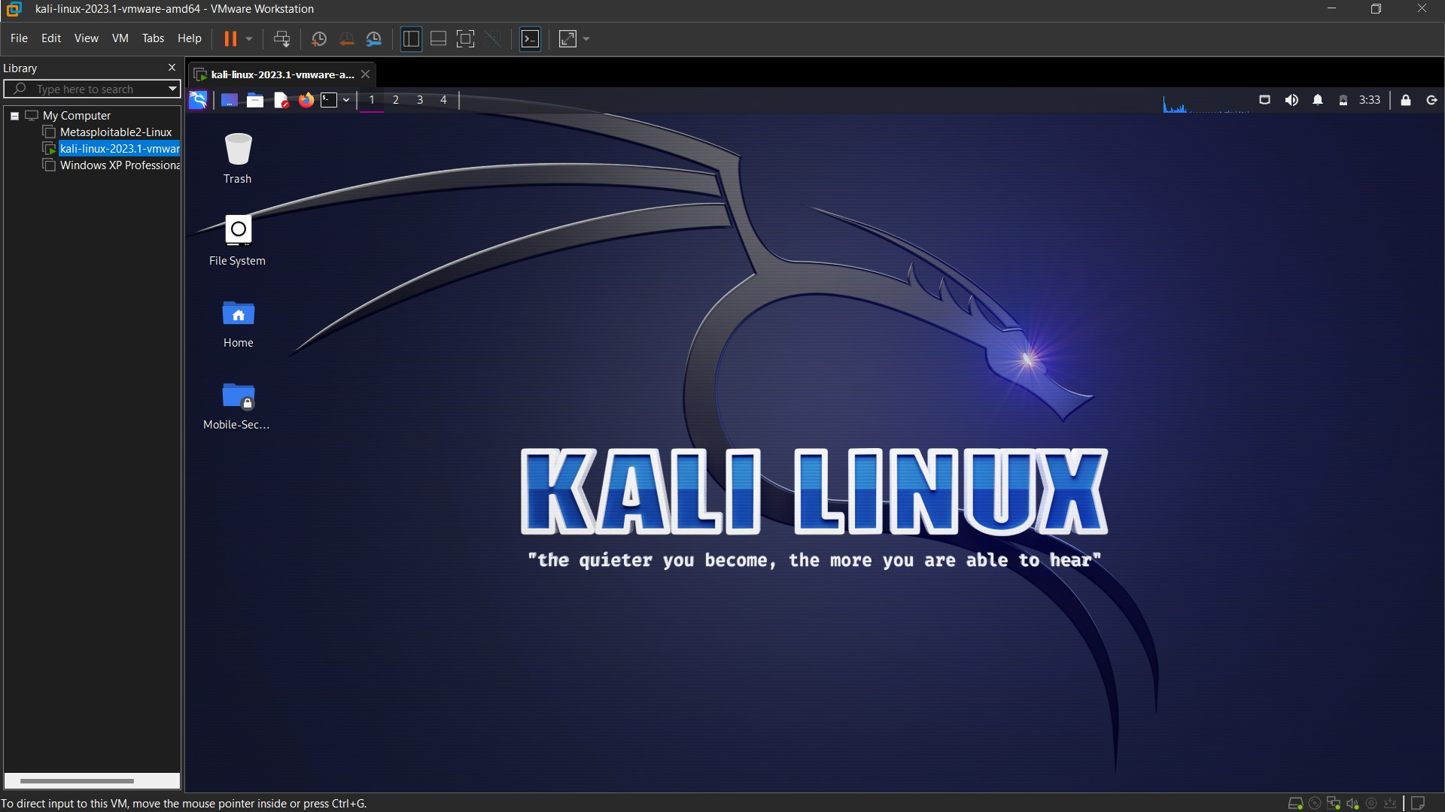

**Installation and Setup of DVWA:** Date: 08/10 Time: 15:45

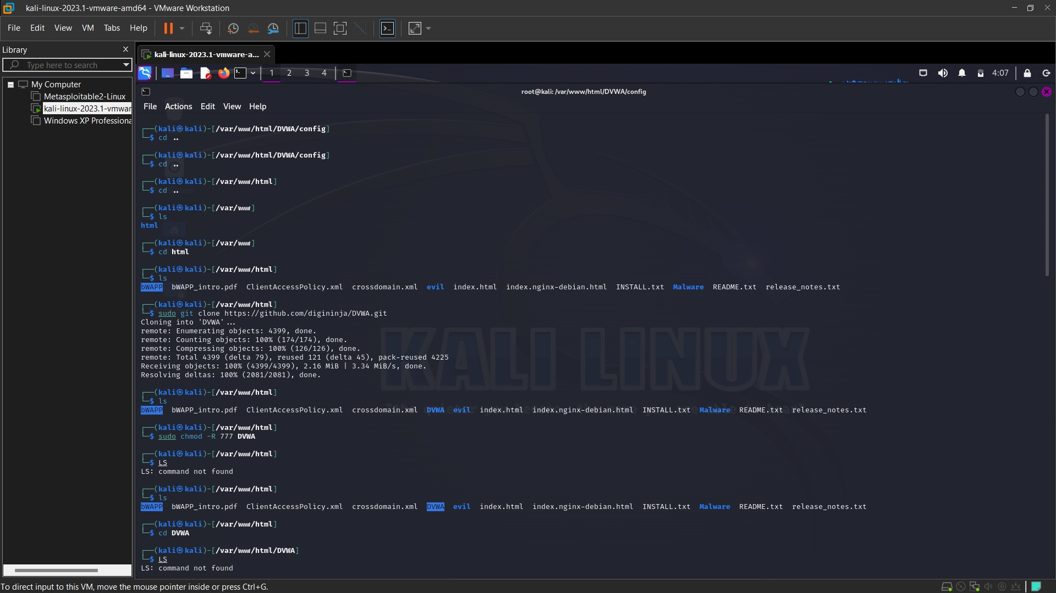

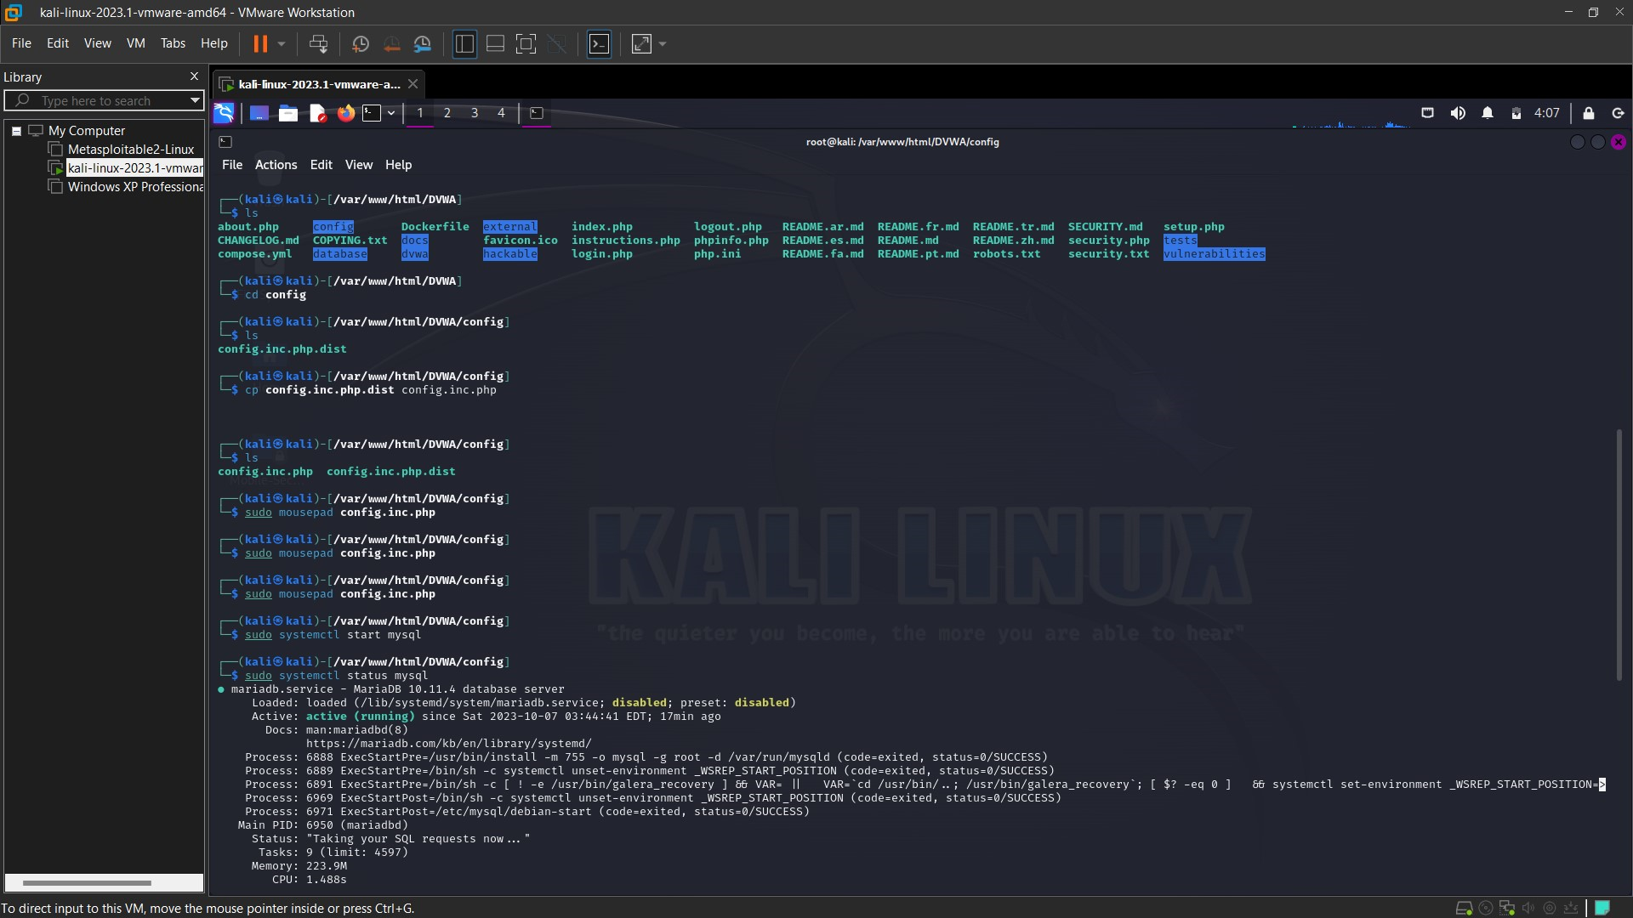

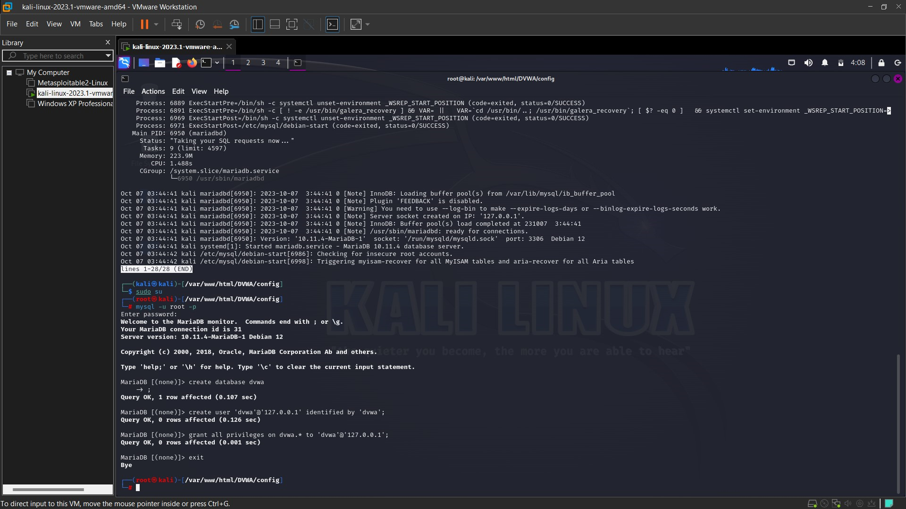

Enter the above-mentioned commands and the DVWA will be installed.

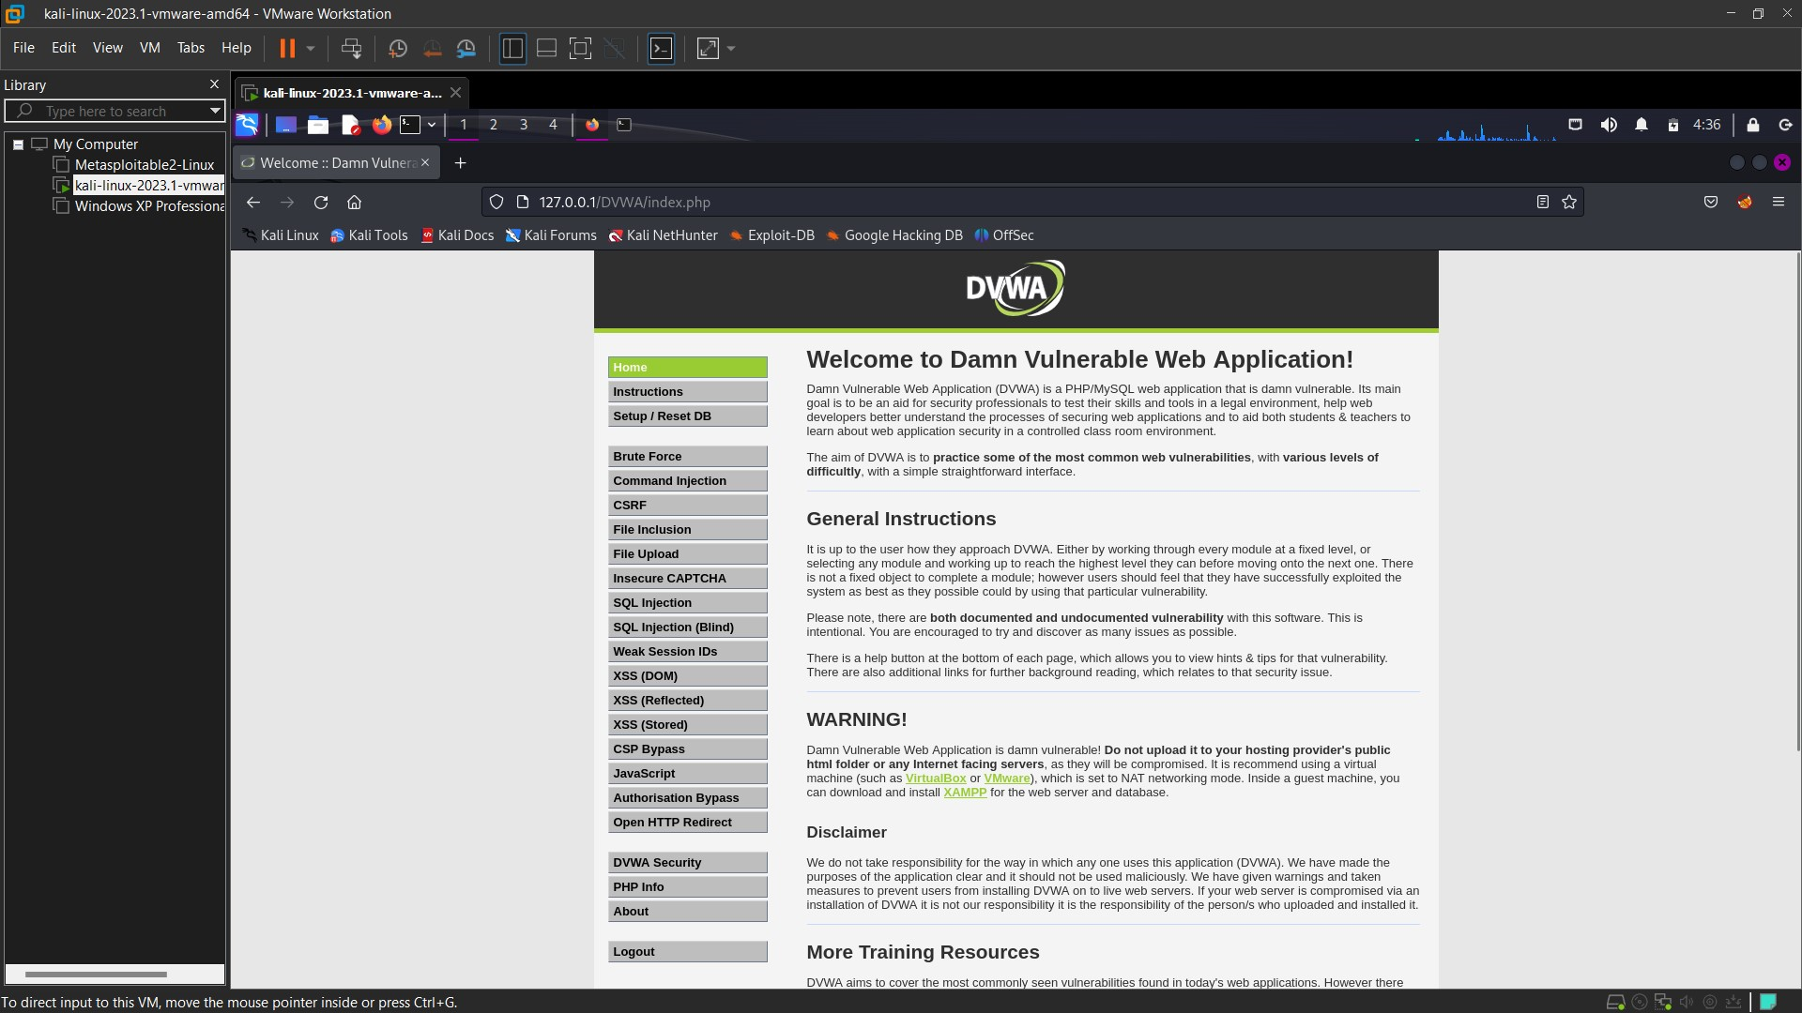

This is the homepage of DVWA. We will see all the vulnerabilities we can exploit.

There are 4 level of security in DVWA which we can set: **Low, Medium, High, Impossible.**

**1. Command Injection:** Date: 08/10 Time: 17:00

When we put a command, it get execute in server side.

Ping a device is used to check the system connectivity is proper or not. If system is alive, it will reply back if the system is not alive it will not reply.

This ping is the feature of server. That means we are directly interacting with server.

**We can ping a device using IP Address or website name:**

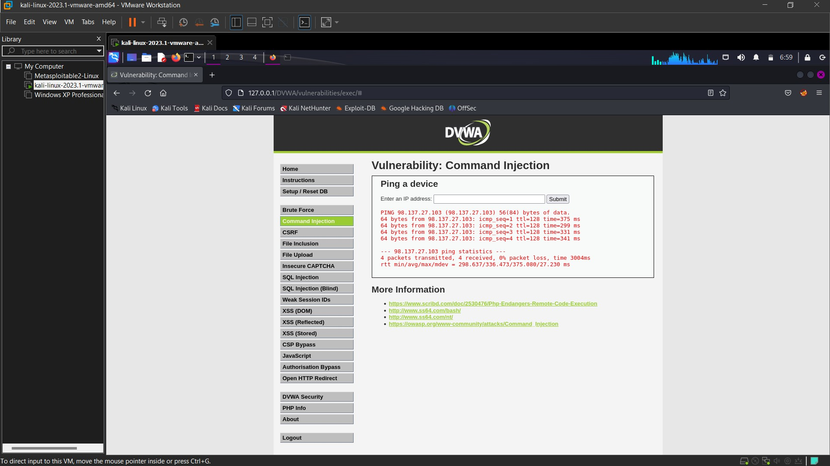 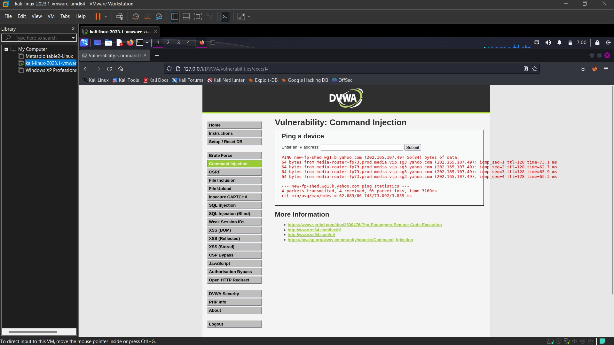

**Low:** We can see the source code using ‘View Source Code’ Button**.** In Low security level we can enter anything in the input field. We can input any symbol or sign and it will get executed in the server.

There is no restriction in the code.

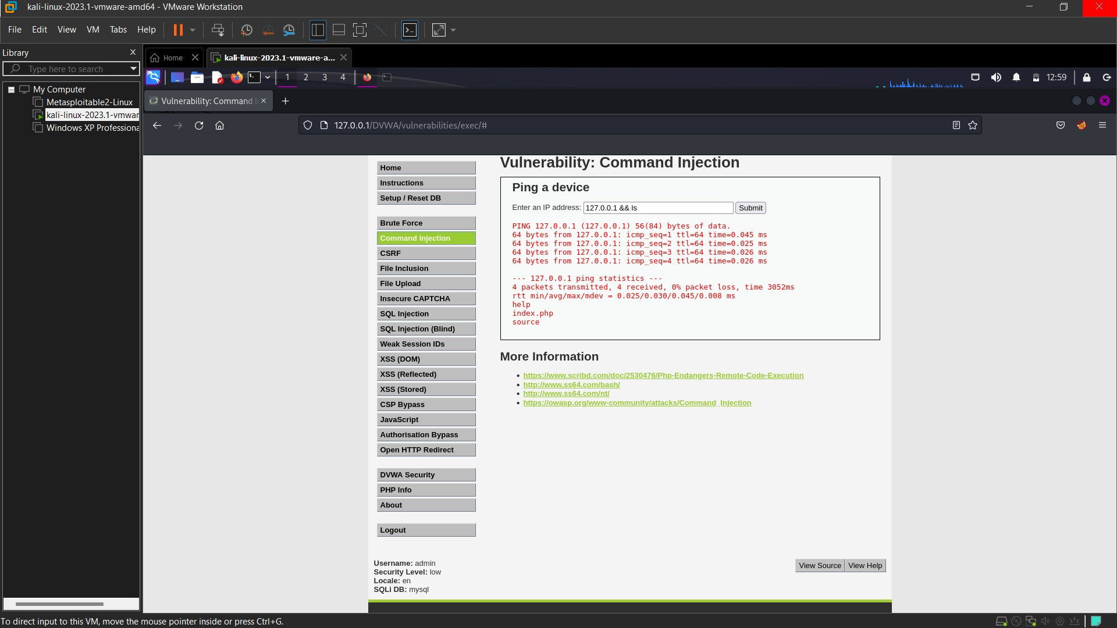

Here I have entered my **‘127.0.0.1 && ls’** – 127.0.0.1 is my localhost and I’m using Kali Linux. The command will ping the localhost and will list all the files in the present directory. So, in the server(localhost) we can get all the files in that directory.

We can enter any Linux command and it will get execute

I have used **‘127.0.0.1 && pwd’** to get the present working directory.

Then I used **‘127.0.0.1 && ifconfig’** to get the IP Address of the server (my own kali Linux IP Address as it is localhost).

**Medium:** If we see the source code of medium level, we see that there is a blacklist block in the code which means entering the blacklisted symbol in our input won’t work and it will be removed.

If we enter the same command i.e., **127.0.0.1 && ls**. It won’t work because it is present in blacklist code.

Now I’ll try **‘127.0.0.1 & ls’** and it worked because ‘&&’ is blacklisted but single & is not blacklisted. This command will ping the localhost as well as list all the files in the present directory.

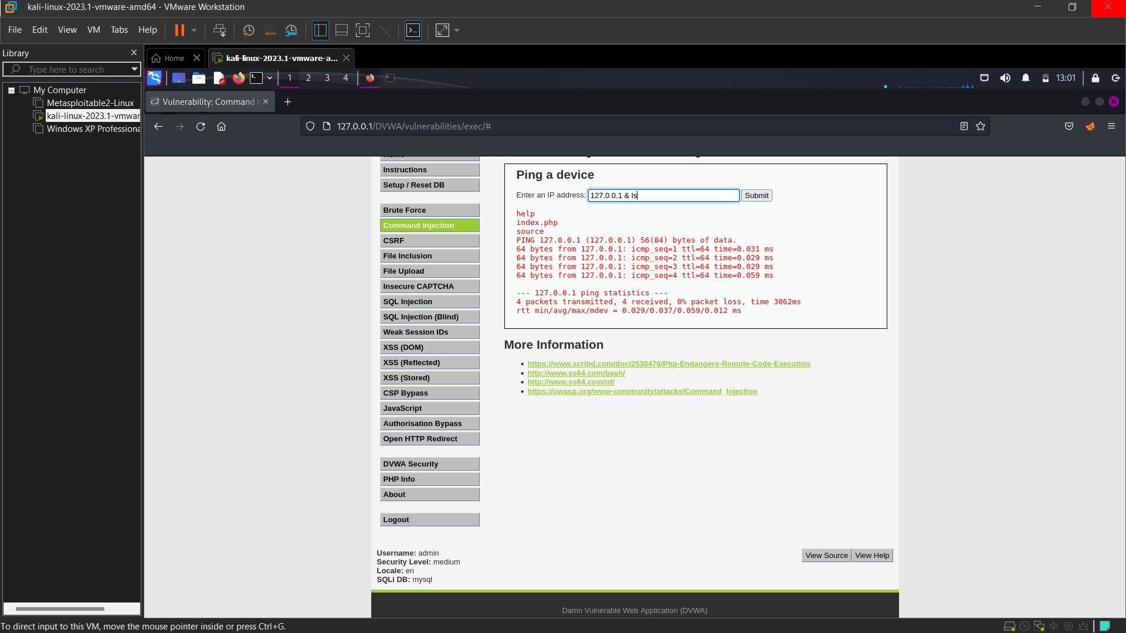

We can also execute **‘127.0.0.1 | ls’** and this will either return us the ping message or it will list all the files in the present directory.

**High:** If we see the source code of high level, we see that the blacklist block in the code now contains many more symbol compared to medium level, which means entering the blacklisted symbol in our input won’t work and it will be removed.

If we enter the same command i.e., **127.0.0.1 && ls**. It won’t work because it is present in blacklist code.

If we enter the same command i.e., **127.0.0.1 & ls**. It won’t work because it is present in blacklist code.

We see the blacklist block has blacklisted **‘| ’** (space)but not **‘|’** (no space). So now will see execute ‘**127.0.0.1 |ls’** and this will either return us the ping message or it will list all the files in the present directory.

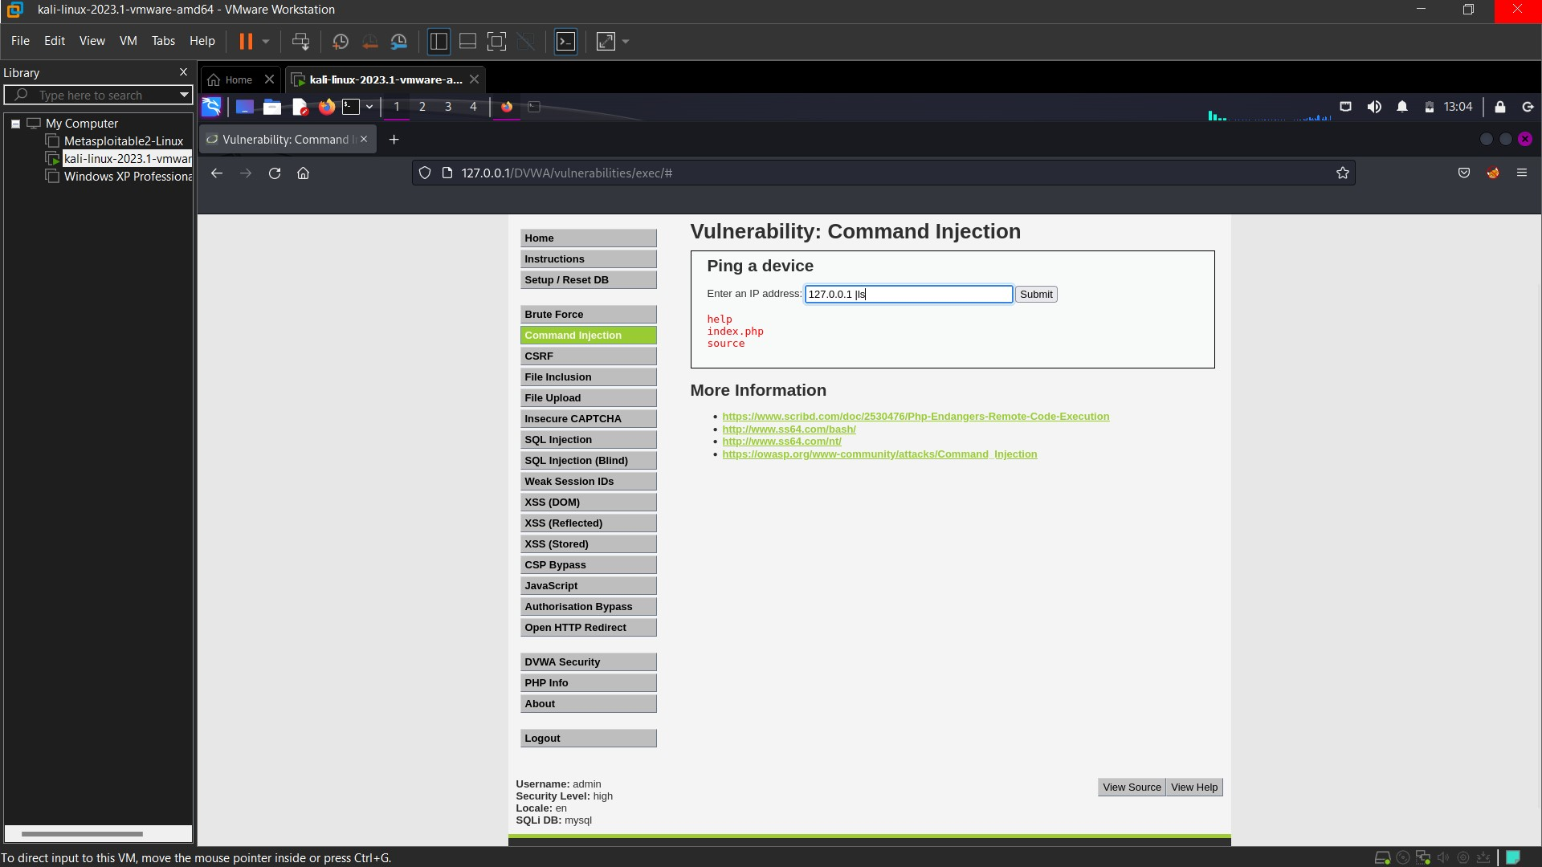

**2. Brute Force:** Date: 08/10 Time: 19:45

A brute-force attack is a trial-and-error method used by application programs to decode login information and [encryption keys](https://www.techtarget.com/searchdatabackup/definition/encryption-key-management) to use them to gain unauthorized access to systems.

A brute-force attack of applications tries all possible combinations of legal characters in a sequence.

[Cybercriminals](https://www.techtarget.com/searchsecurity/definition/cybercrime) typically use a brute-force attack to obtain access to a website, account or network. They may then install [malware](https://www.techtarget.com/searchsecurity/definition/malware), shut down web applications or conduct data breaches.

We will use burpsuite to brute force attack on dvwa.

**Low:**

We will use intruder to perform brute force.

First, I’ll start the intercept. Then I’ll enter any random password and the burpsuite will intercept it. And I’ll send that intercepted request to intruder.

In intruder we will use sniper as our payload because we only had to brute force password. So, we will select the password and click on add. Then we will go to payload session and create a simple list.

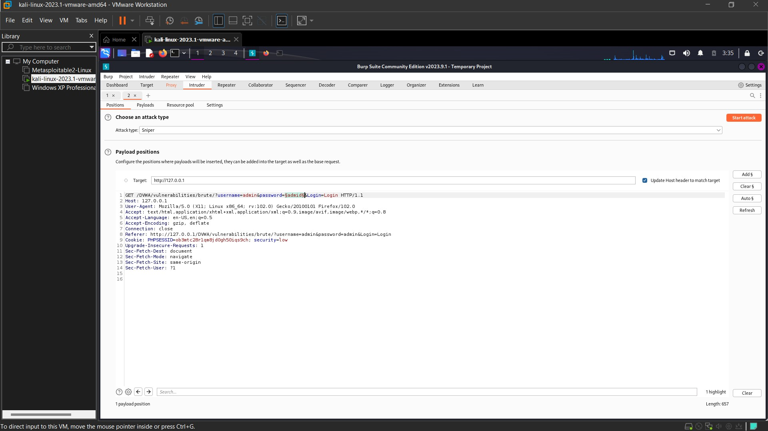

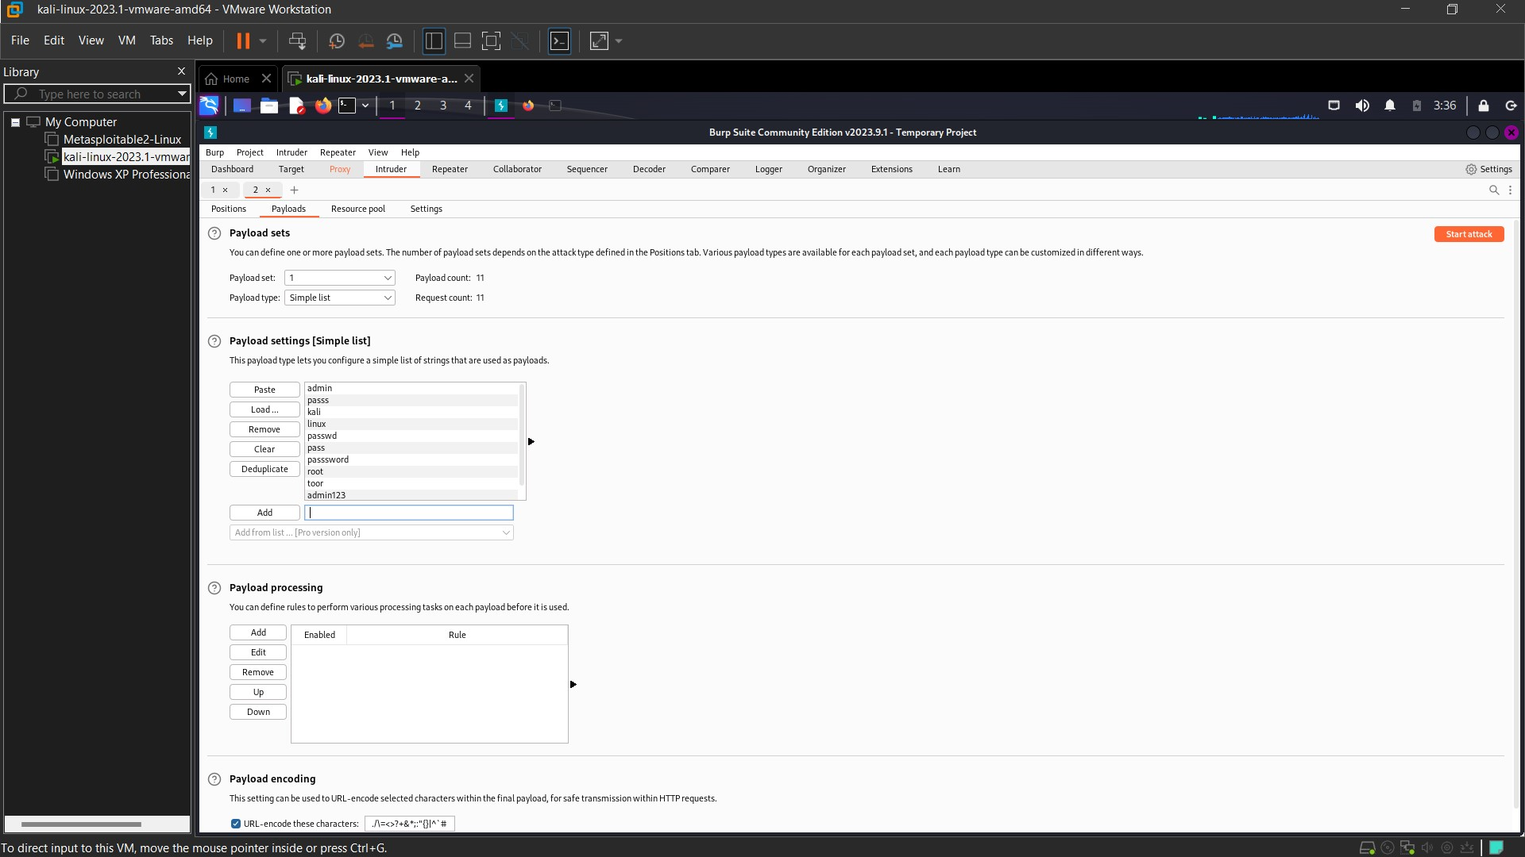

And in the list, I’ll enter the common passwords. And then we will start the attack. You can see the length of some is different. Means one of those is our password.

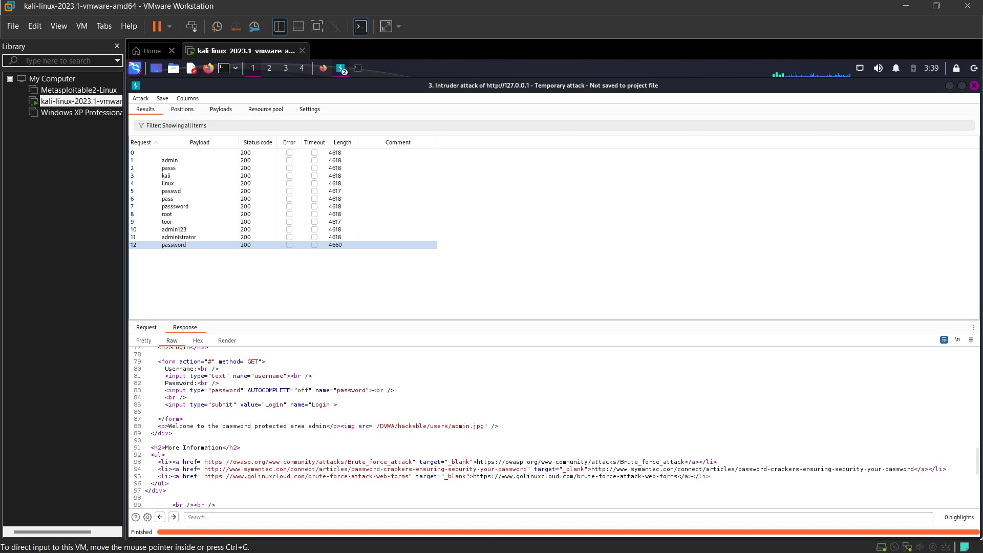

And we got our password as **‘password’**. And in low security if we see the code using ‘view source’ we can see there is no sleep time. Which means we can continuous brute force the password without break.

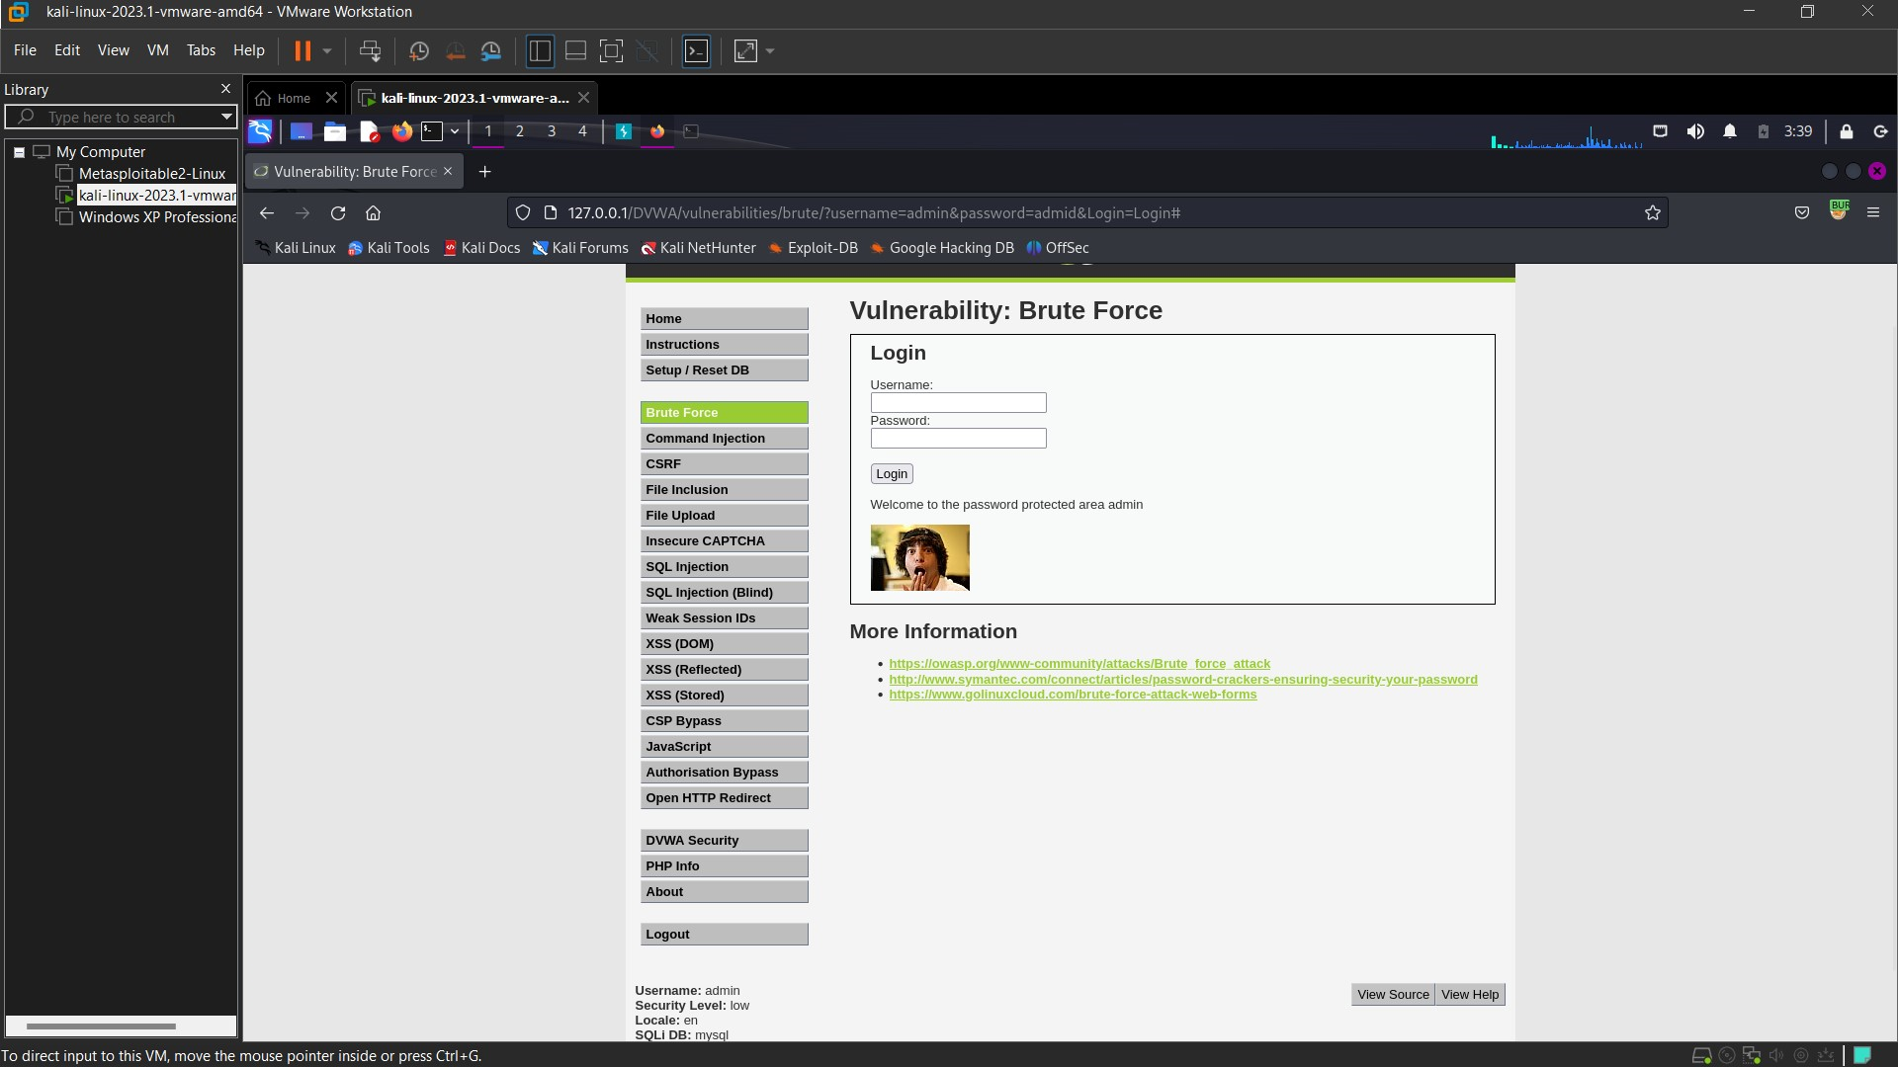

**Medium:** In Medium level security there if we see the code. There is a sleep time of 2 seconds. Meaning if we entered wrong credentials, the website will go to sleep and we can’t enter username & password during that time.

And if we brute force now it will take time as after each attempt it will stop for 2 seconds.

So, I’ll use the same list as before. And follow the same procedure as before.





After each request I waited to 2 seconds and finally we got our password as ‘**password**’. Or we can use options which will send request after some time where we can set the time. So we can set 2 second and burpsuite will itself send request after every 2 second till it get the password.

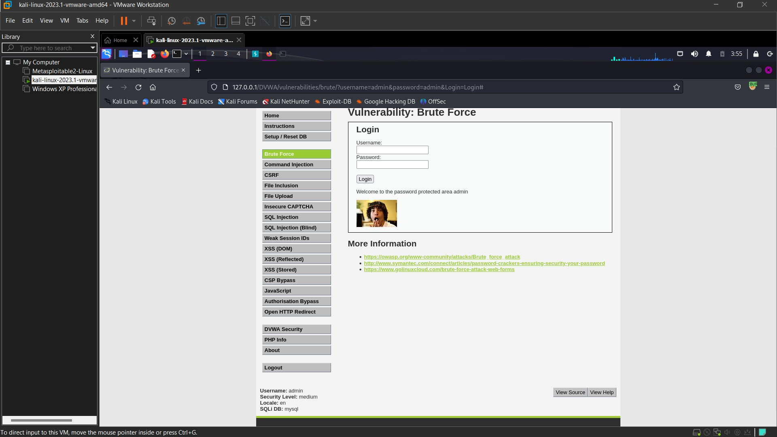

**High**: In high level security there if we see the code. There is a sleep time of 3 seconds. Meaning if we entered wrong credential, the website will go to sleep and we can’t enter creds during that time.

But now we also see generatesessiontoken(). Now this token should be provided to access the website even if we enter the right creds.

If we enter the right creds but couldn’t provide the right token, we won’t be able to access the website.

We can bypass this by using burpsuite

In burpsuite go to settings > session > add a rule action > select run a macro > Add your latest request which contains a user token.

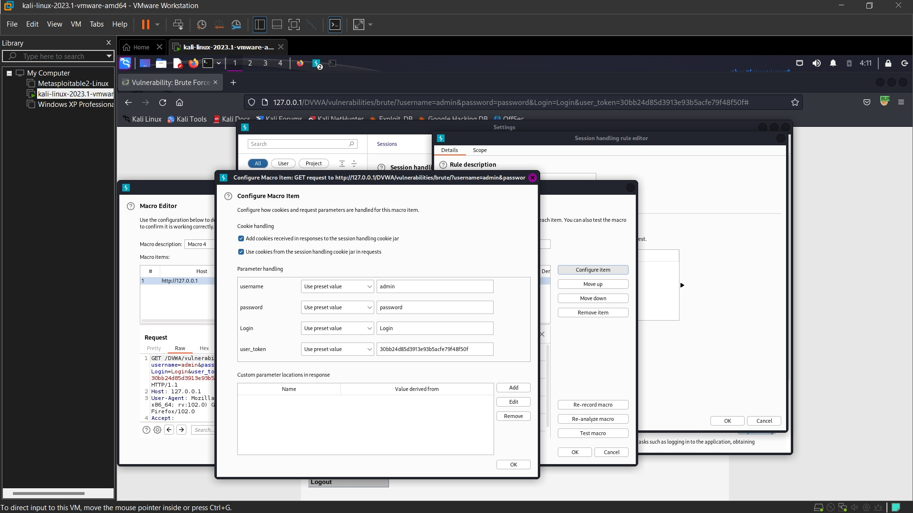

Then click on tolerate URL. Then go to scope deselect everything except intruder.

We did all of thing because once the token is generated burpsuite will store that token and then send the request and when response will come it will enter the stored token and then login.

And we can bypass the token issue.

Now I’ll enter username and password but the intercept is off in burpsuite. It will give the following error:

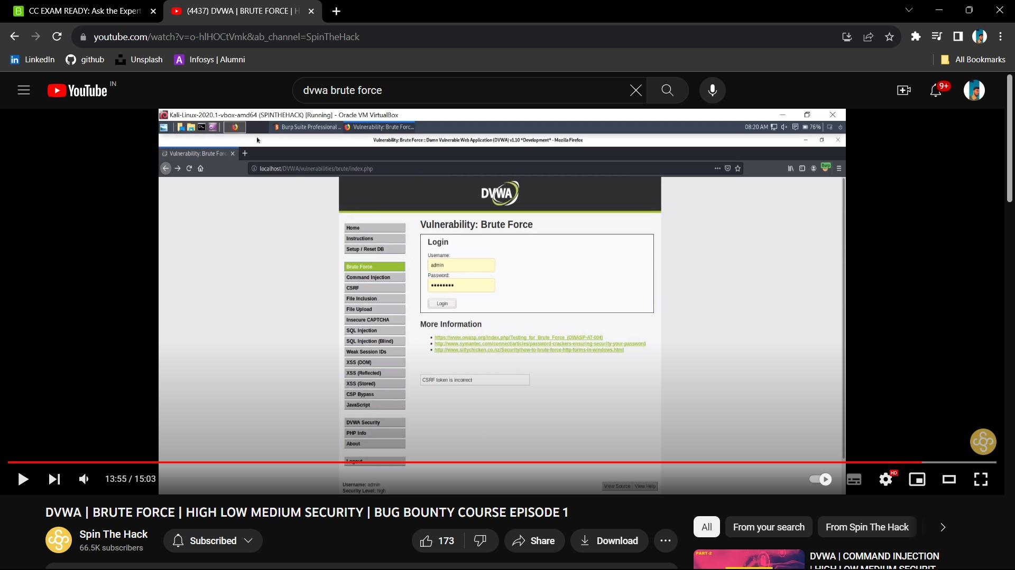

Now I will start the intercept, now it will store the token and use it later.

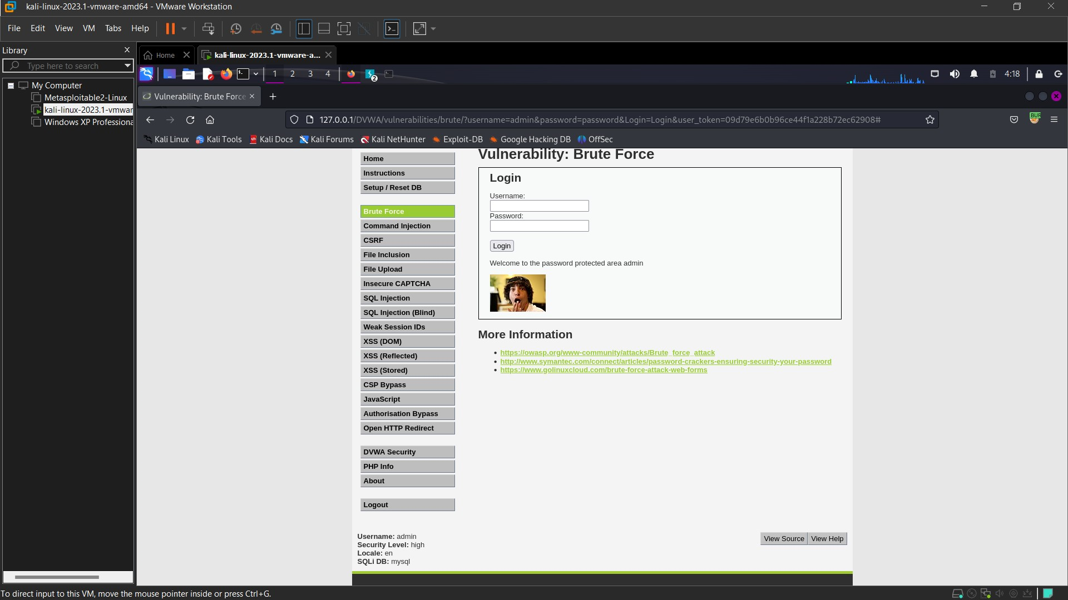

Once the intercept is on, we can enter the password and it will allow us to pass.

**3. SQL Injection:** Date: 08/10 Time: 21:30

SQL injection usually occurs when you ask a user for input, like their username/userid, and instead of a name/id, the user gives you an SQL statement that you will **unknowingly** run on your database.

Now in DVWA we entered 1,2,3,4,5 as input and we got First name and surname that is stored. But when we enter 6, we got nothing as there is no value for ID 6.

To check if this website is vuln to SQL injection I’ll just type **‘** and submit. We got and error. That means we can apply SQL injection in this website.

**Low:** If we check the code, we can see a query ‘Select first_name, last_name from users’. That means there is a table user in the database. The meaning of that code is whatever user id im giving give me the first and last name.

This is the query from the code: **"SELECT first_name, last_name FROM users WHERE user_id = '$id';”;**

And when we give any input it get substitute in ‘$id’

Now I’ll will try to extract username and password

For that I’ll type = **1' UNION SELECT user,password FROM users#**

And this will get substitute in place of id and the query will look like this: **SELECT first_name, last_name FROM users WHERE user_id = ‘1' UNION SELECT user,password FROM users#**

Now the server will return everyone username and password

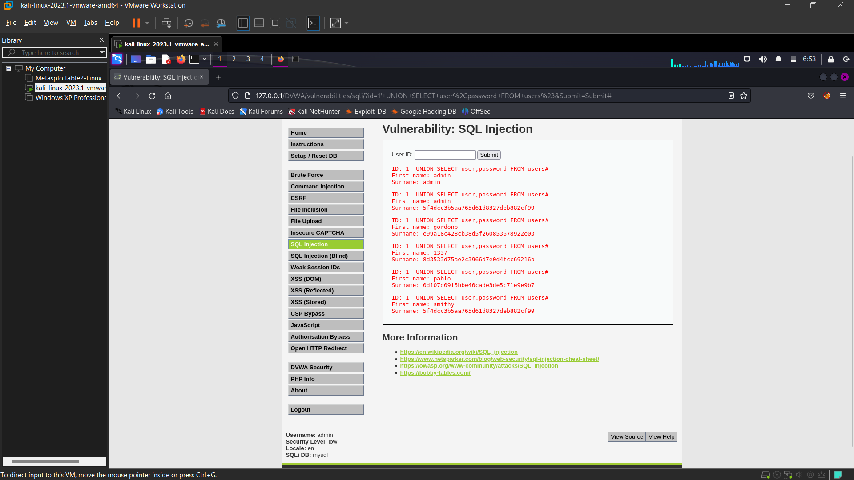

UNION is used to add two queries together. First it will give me First_name and Surname of ID: 1 then it will give me username and password of all.

But we see that the password is stored in Hash Method. To extract the password from the hash we will use crackstation.net. And we can extract each and every ID’s password.

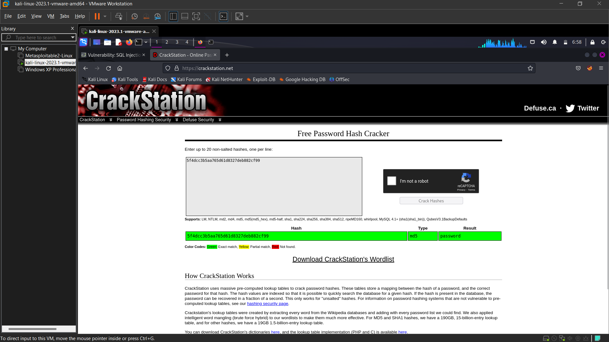

**Medium:** In medium we can’t insert any query. Now we will use burpsuite and its repeater.

Now we will start the proxy interceptor and then we will select 1 and click on submit.

The interceptor will intercept the request, and we will send that request to repeater.

And we already have a payload and we will use that in the repeater.

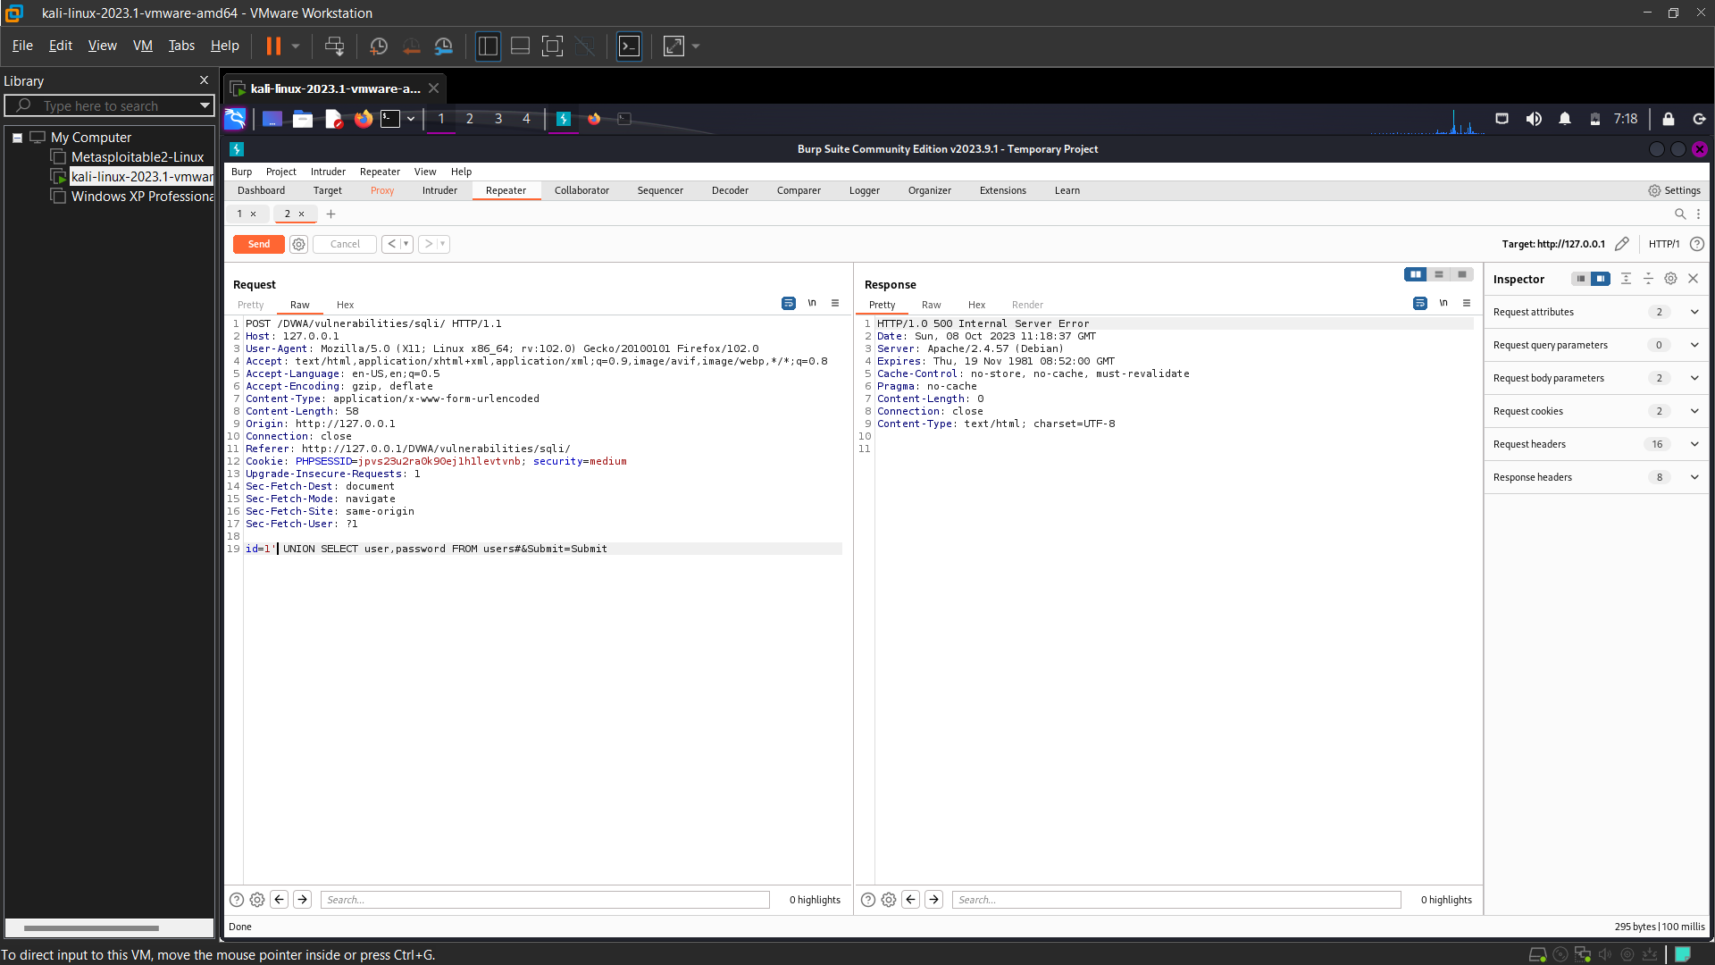

But we did not get the response, there is 500 internal server error. It may have happened because they may have blacklist ‘.

I’ll remove the ‘ and try again.

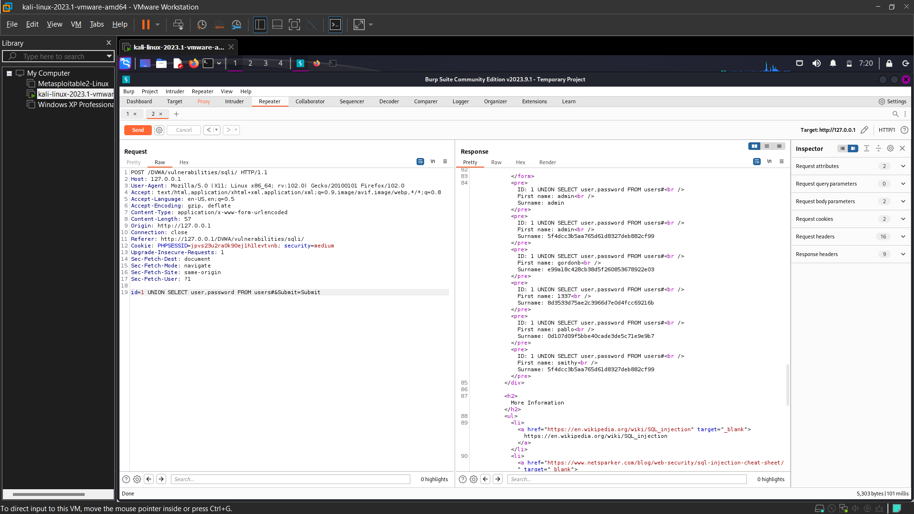

And we get the response, scroll down and we will get the username and password.

So, we got to know there was a blacklist of some symbol and one of them was ‘.

After removing ‘ our payload worked.

**4. File Upload:** Date: 09/10 Time: 08:30

Uploaded files represent a significant risk to web applications. The first step in many attacks is to get some code to the system to be attacked.

Then the attacker only needs to find a way to get the code executed. Using a file upload helps the attacker accomplish the first step.

File upload vulnerabilities are when a web server allows users to upload files to its filesystem without sufficiently validating things like their name, type, contents, or size.

Failing to properly enforce restrictions on these could mean that even a basic image upload function can be used to upload arbitrary and potentially dangerous files instead. This could even include server-side script files that enable remote code execution.

**Low:**

So, now I created a simple php file named **‘aim.php’**. Which contains only 1 line: **<? php system($_REQUEST["cmd"]); ?>**

As low security does not have any restriction, we can upload any type of files.

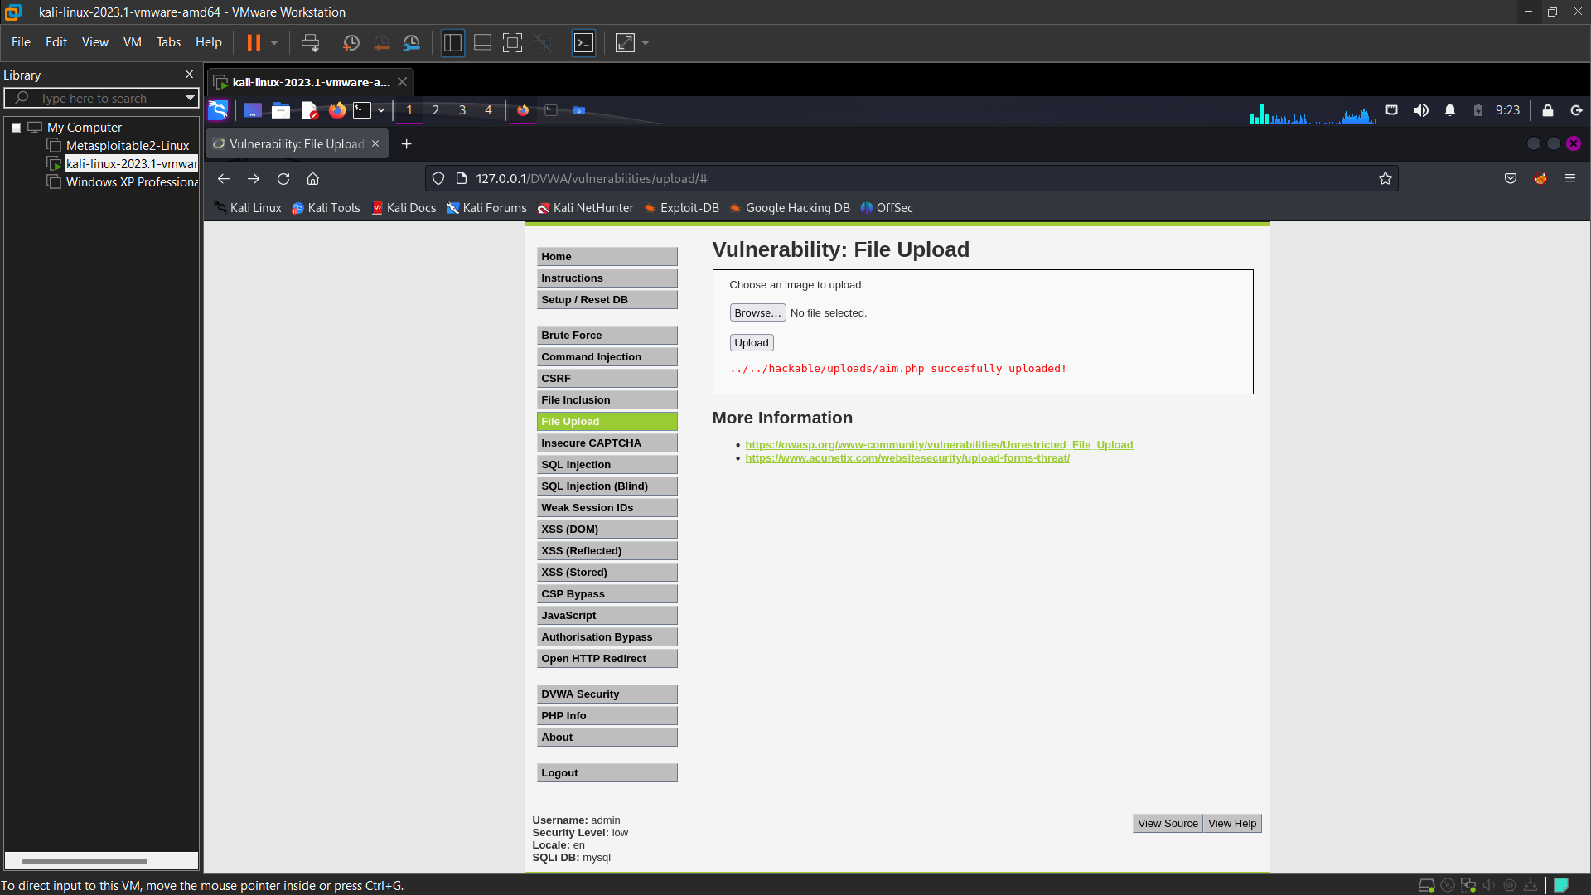

Our file got uploaded in hackable/uploads folder.

Now we will try the vulnerability by changing the url to the path we got. We will change the URL to: 127.0.0.1/DVWA/vulnerabilities/upload/../../hackable/uploads/aim.php.

We got a blank page. But our php file has request cmd. Now we will just add **‘?cmd=ls’** in the URL. And we will get the list of files in that directory.

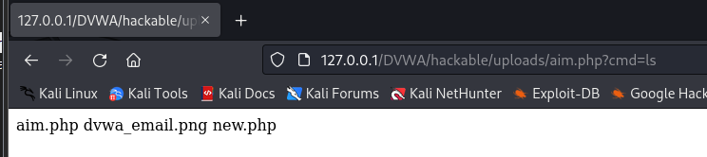

Now we will just add **‘?cmd=pwd’** in the URL. And we will get the current working directory.

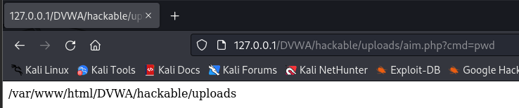

We can put any Linux command and it will work.

**Medium:**

If we check the code of medium security, we see now it have code for Name, Type, Size.

It will only accept image that also only in JPEG and PNG. We now can’t add any files other than JPEG and PNG. Size of that Image file also matter.

Here the content type of the file is checked. If we change the content Type, the file may get uploaded. To change the content type, we will use Repeater of burp suite.

Upload the exploit file. I just used the old php file but changed it name to **‘medium.php’** and intercept that request with burpsuite. And send that request repeater. First directly send the request and get the response.

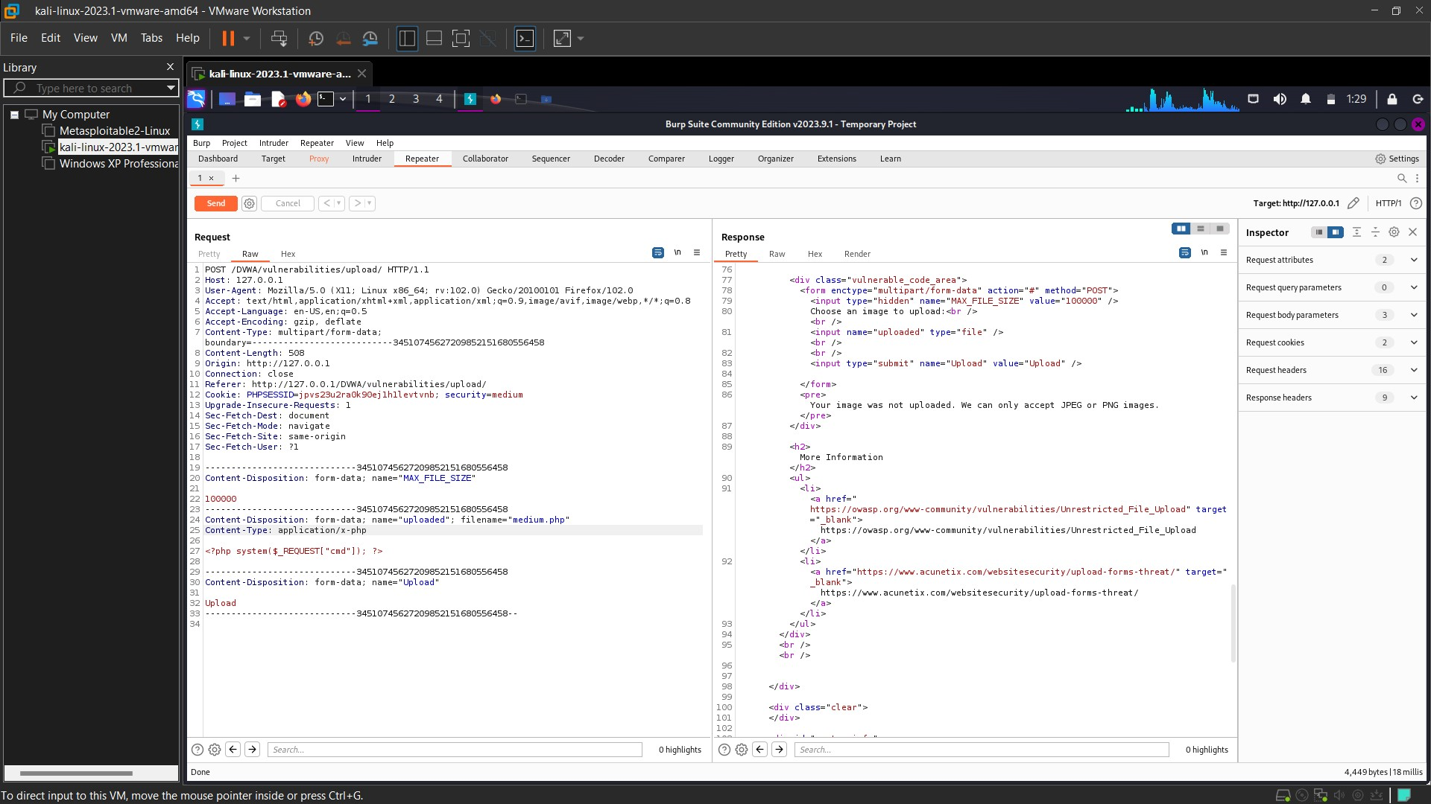

We got the error that our php can’t be uploaded. As only png or jpeg is accepted.

So now I changed the content type to ‘image/png’. And our php file was accepted.

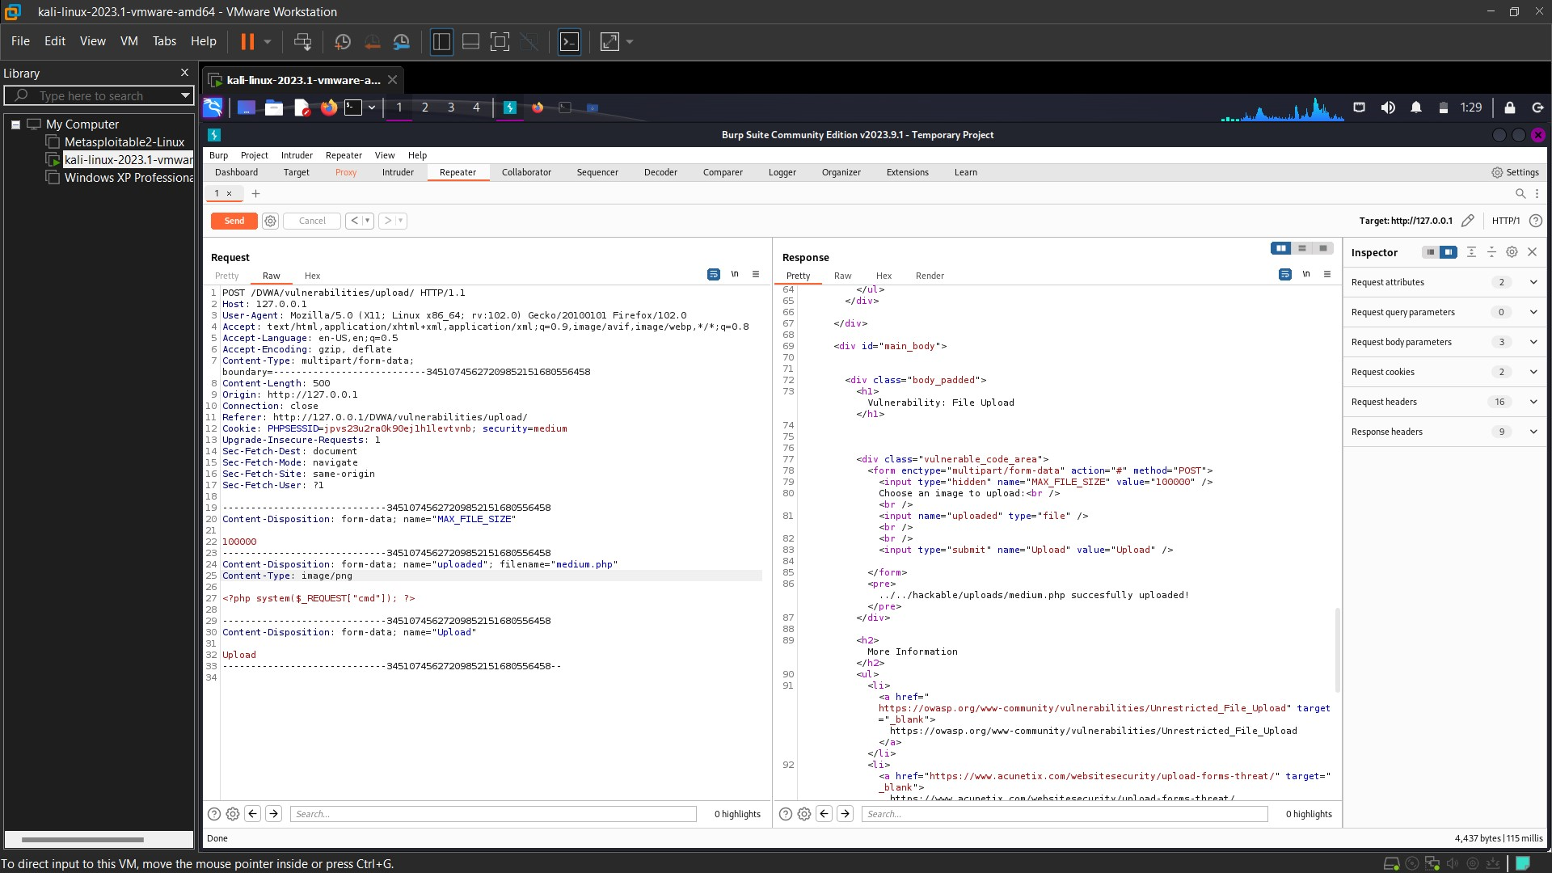

Our file got uploaded in hackable/uploads folder.

Now we will try the vulnerability by changing the url to the path we got. We will change the URL to: **127.0.0.1/DVWA/vulnerabilities/upload/../../hackable/uploads/medium.php.**

We got a blank page. But our php file has request cmd. Now we will just add **‘?cmd=whoami’** in the URL. And we will get the name of the present user.

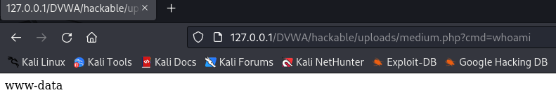

Now we will add **‘?cmd=ls’** in the URL. And we will get the list of files in that directory. We can see our medium.php is present.

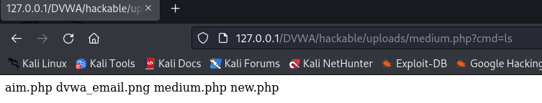

**5. Stored XSS:** Date: 09/10 Time: 11:00

In a Stored XSS attack, the vulnerable web application receives user-supplied input from untrusted sources and stores it. This malicious content also gets included in the later HTTP responses sent by the server.

To perform a Stored XSS attack, hackers only need to identify a security vulnerability within the backend application that allows executing malicious requests.

This makes it more exploitable as hackers do not need to craft external methods for supplying untrusted inputs to the target application server.

Stored XSS, also known as Type-1 or Persistent XSS attacks, typically rely on unsanitized user input points for scripts permanently stored on the target servers. Since these attacks allow malicious users to control how the browser executes a script, they can typically facilitate a complete user account takeover.

The XSS is stored in the database. The XSS is permanent, until the database is reset or the payload is manually deleted.

**Low:** The low security doesn’t have any protection. And we can run any scripts in the message box or in the name.

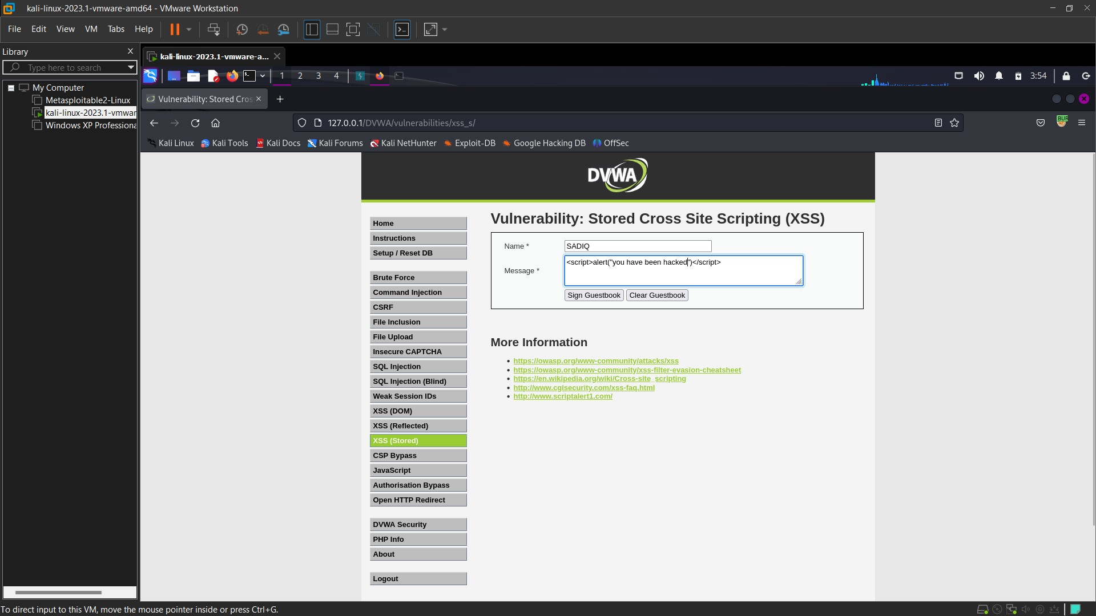

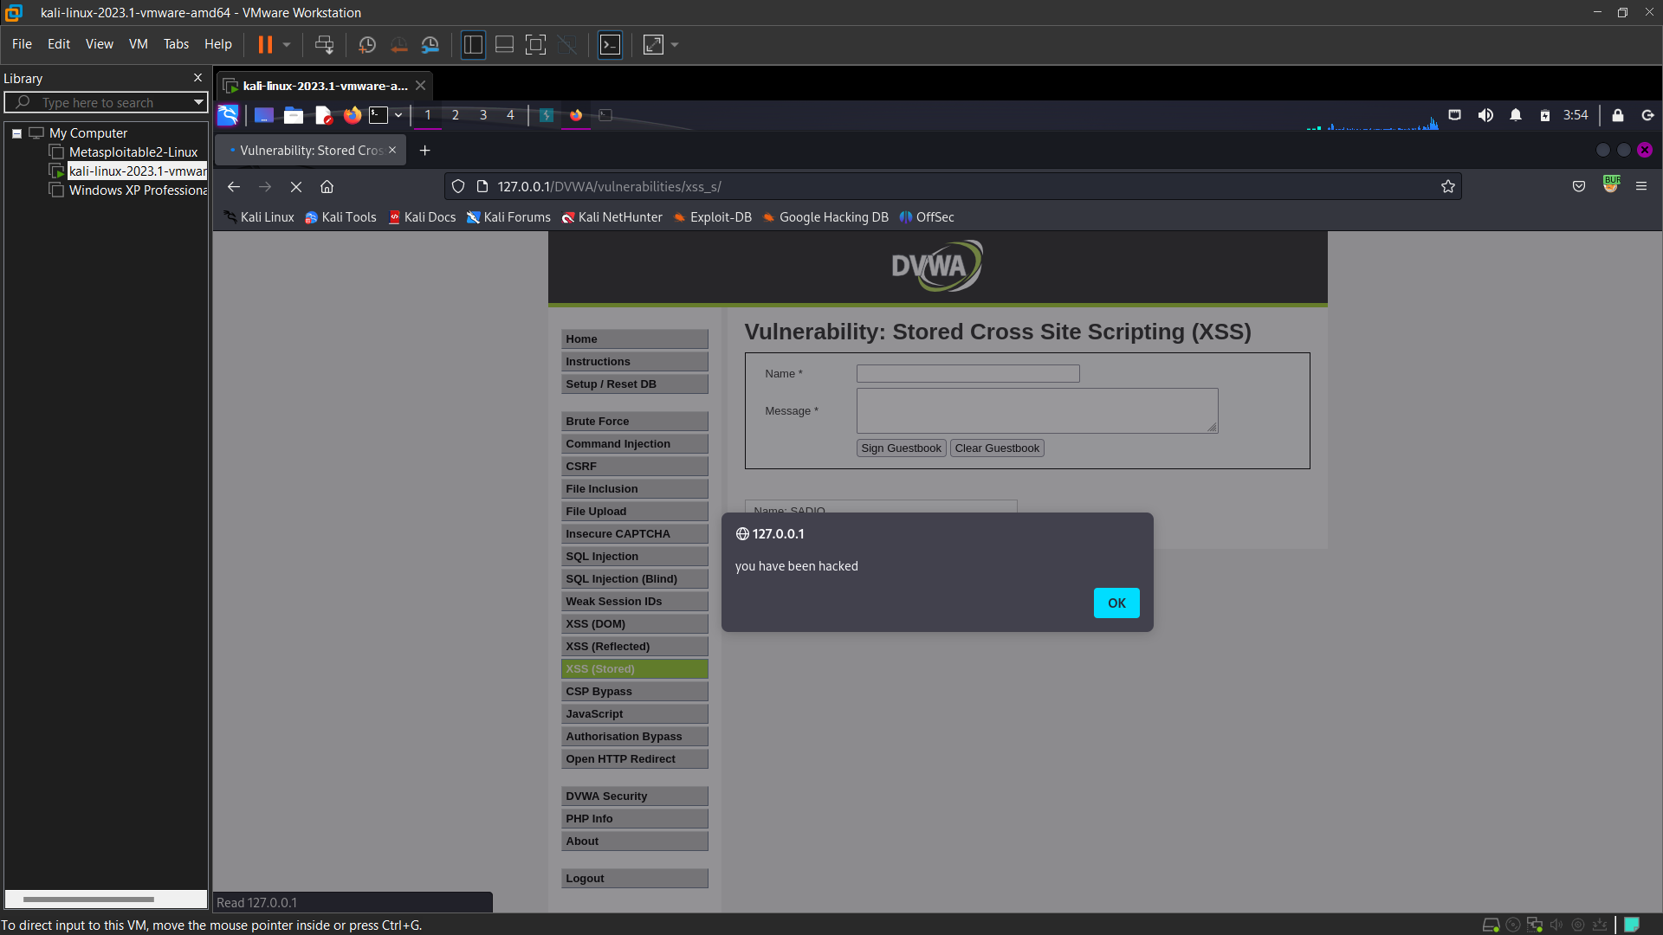

I have written the script directly in the message box. And it got executed. Now if I refresh the page or revisit the page, I will get the alert again and again.

We see the URL is clean and no malicious thing is present. But it is infected and if I send that URL to anyone that person will get the alert box.

Because the script is now stored in the server. Until the script is deleted or server is reset it will get alerts.

We will now try to redirect the user to a different website. For that the website should be in our server.

**Medium:** In medium tags and whitespaces are removed in messages. So, we can’t script in medium level as tags are removed. In the name also we can’t add script as **‘<script>’** will be removed.

**So we will add script inside script tag so one script will be removed but the outside one will form the word script and our exploit will work.**

But the name only takes 10 characters. So, we will change that using inspect.

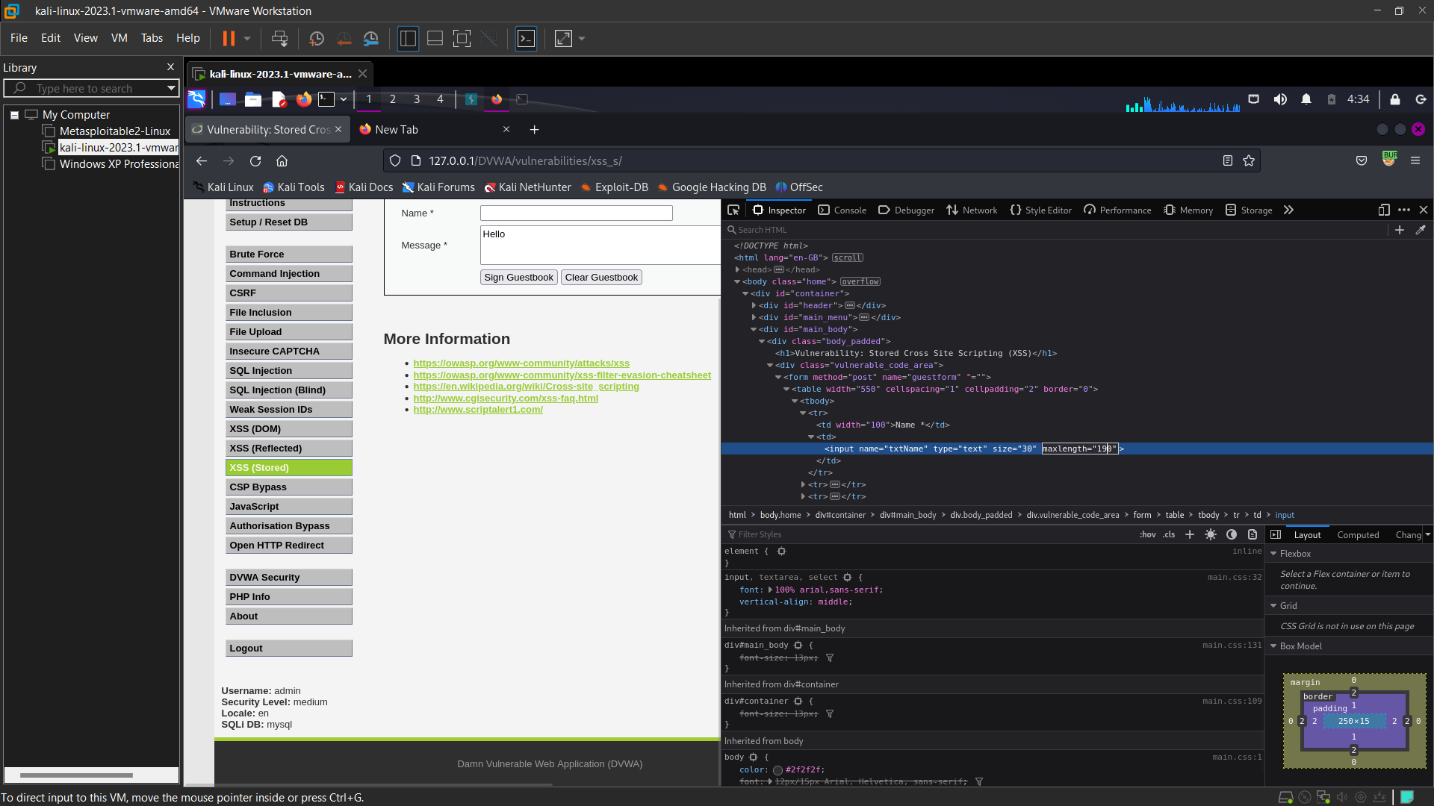

I changed it to 190 characters. Now we can enter our script in Name.

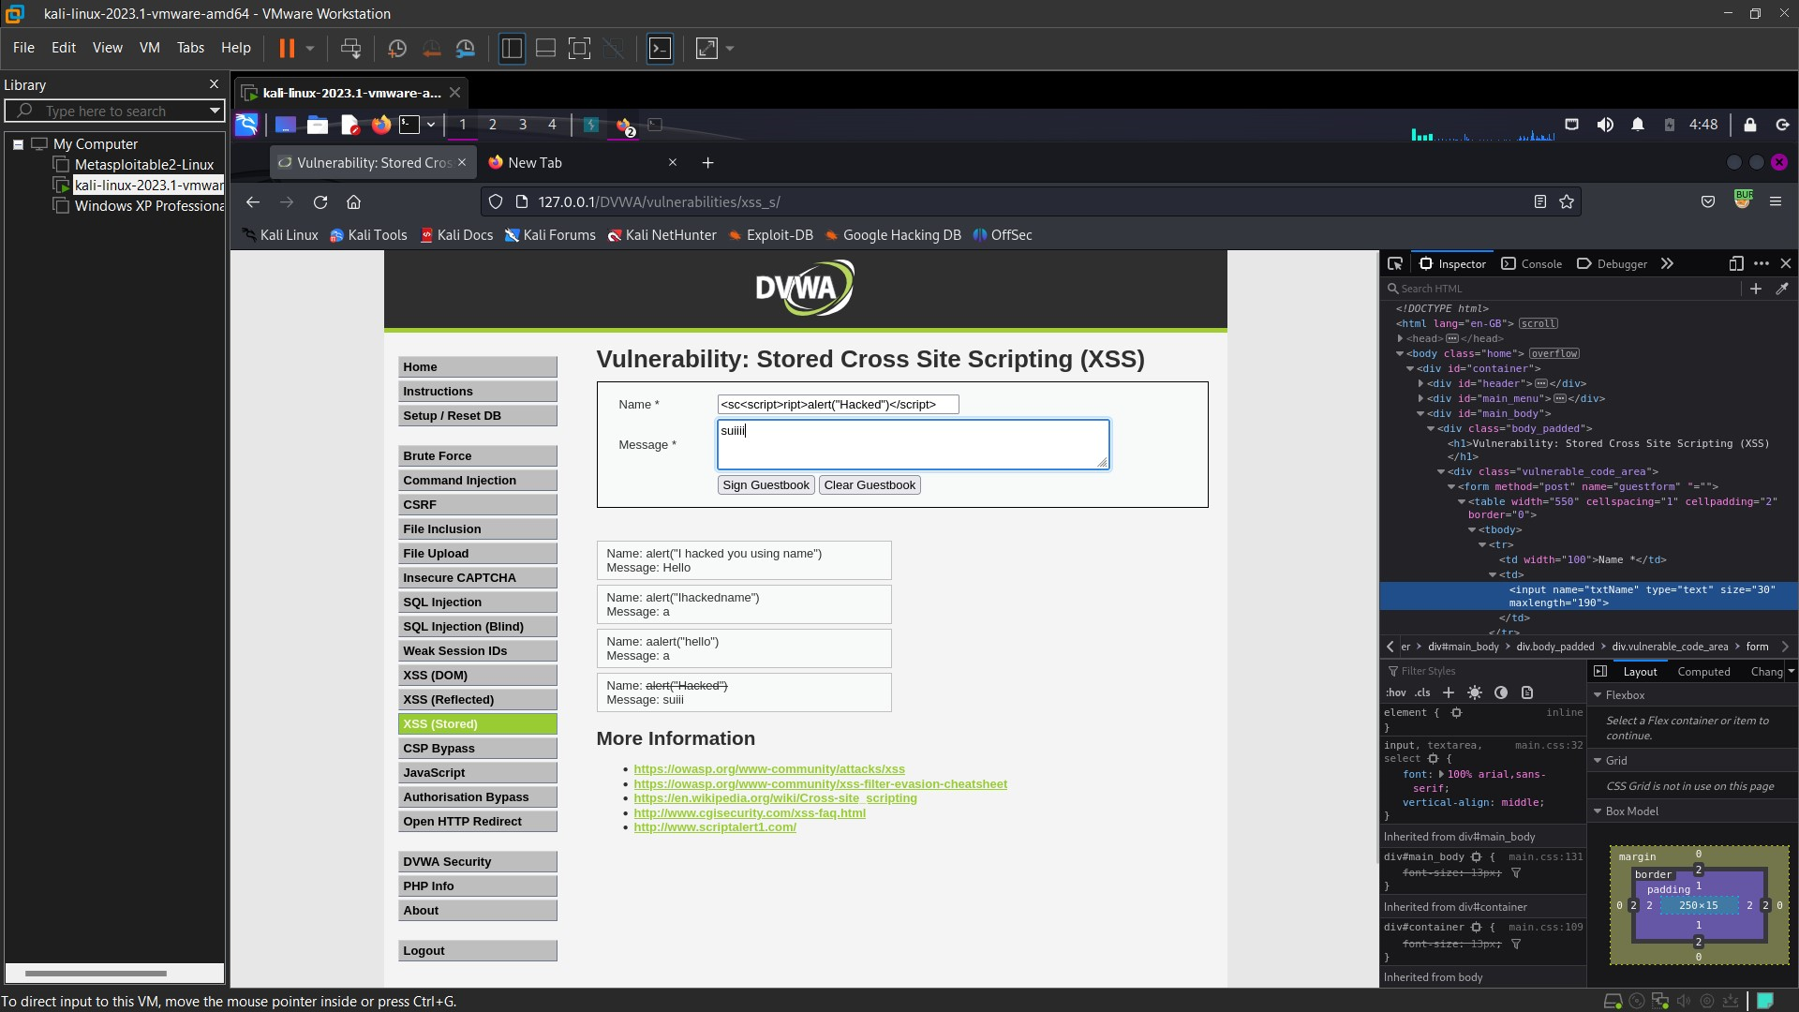

You can see I add script inside another script. **The security removed the script which is inside But in turn the outside sc and ript come together and form the word script.** Which allow us to run our exploit.

